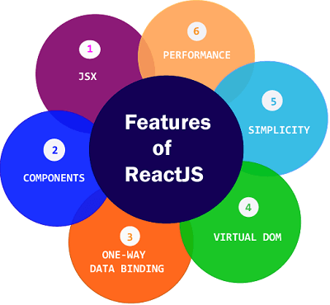

* JSX
* Components
* One-way Data Binding
* Virtual DOM
* Simplicity
* Performance
* **Reference**

<https://www.javatpoint.com/react-features>